Mandatory Experiment 4.1

Preparation of a standard solution of sodium carbonate

Student Material

Theory

A standard solution is one whose concentration is accurately known. A primary standard is a substance that can be used to make a standard solution directly. A primary standard such as anhydrous sodium carbonate is available in a pure state, is stable and is water-soluble.

Anhydrous sodium carbonate (Na₂CO₃) has a molar mass of 106 g mol⁻¹. A 0.1 M solution is made up, using a 250 cm³ volumetric flask. For 250 cm³ of 0.1 M sodium carbonate solution, the mass required is:
106 x 0.1 x 250 / 1000 = 2.65 g

Chemicals and Apparatus

Anhydrous sodium carbonate _{i}
Deionised (or distilled) water

Balance (accurate to 0.01 g)
Clock glass
Beaker (250 cm³)
Wash bottle
Stirring rod
Volumetric flask (250 cm³) and stopper
Filter funnel
Safety glasses
Dropping pipette

Procedure

NB: Wear your safety glasses.

- Using a balance, measure accurately 2.65 g of pure anhydrous sodium carbonate on a clock glass.

- Slowly transfer the sodium carbonate with stirring, to about 50 cm³ of deionised water in a clean 250 cm³ beaker. To ensure that all the sodium carbonate is transferred, use a wash bottle to rinse the clock glass with deionised water, and add the rinsings to the beaker.

- Continue stirring the mixture with a stirring rod until the sodium carbonate has fully dissolved.

- Using a wash bottle, wash off the solution on the stirring rod with deionised water into the beaker.

- Pour the solution through a clean funnel into the 250 cm³ volumetric flask.

- Using a wash bottle, rinse out the beaker several times with deionised water, and add the rinsings to the solution in the flask.

- Rinse the funnel with deionised water, allowing the water to run into the flask.

- Fill the flask to within about 1 cm of the calibration mark, and then add the water dropwise, using a dropping pipette, until the bottom of the meniscus just rests on the calibration mark.

- Stopper the flask and invert it several times to ensure a homogeneous (evenly mixed) solution. Label the flask.

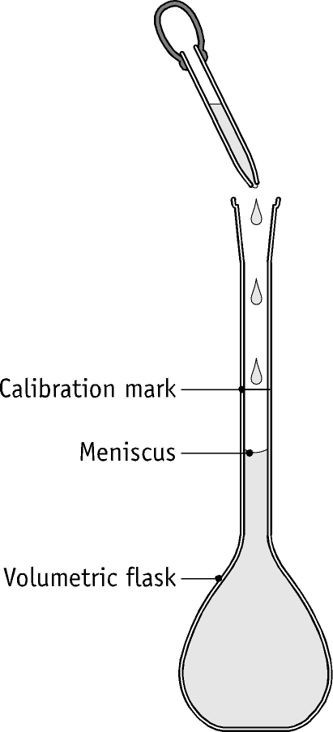

Questions relating to the experiment

- (i) What is a standard solution?
(ii) Why is it possible to make up a standard solution of sodium carbonate directly?

- In this experiment:
- What precaution is taken to ensure that all of the weighed sodium carbonate is transferred from the clock glass to the beaker?
- Why is a stirring rod used?
- Why is it necessary to wash the solution off the stirring rod into the beaker?
- Why are the rinsings from the beaker added to the volumetric flask?
- Why is it necessary to be particularly careful when adding the last few drops of water to the volumetric flask?
- When the solution has been made up, why is it necessary to mix the contents of the flask thoroughly? What feature of the volumetric flask makes this particularly necessary?
- Why is a beaker, rather than a conical flask, used when the solute is being dissolved?
- Why is a funnel used in transferring the solution from the beaker to the volumetric flask?
- Why is it necessary to slowly add the solid sodium carbonate, with stirring, to the water in the beaker?

Teacher Material

- For maximum accuracy, analytical reagent-quality (A.R.) anhydrous sodium carbonate should be used.

- A weighing boat may be used instead of a clock glass.

- In this experiment, the volumetric flask is stoppered and inverted several times to ensure that the solution is homogeneous (uniform). The shape of a volumetric flask allows accurate measurement of volume (narrow neck at the point of calibration) but is not well designed for easy mixing of its contents.

- The solution must not be warm when it is being made up as (i) it will contract when cooled back to room temperature, thus altering the number of moles per litre and (ii) volumetric flasks are calibrated at a specific temperature (20 ⁰C).

- Other situations to avoid include the following:
- Contamination from dirty glassware
- Sodium carbonate becoming lumpy
- ‘Overshooting’ the mark

Preparation of reagents

Anhydrous sodium carbonate:
Dehydrate by heating to 260 – 270 ºC for 30 minutes, and allow to cool in a desiccator before use.

Quantities per working group

2.65 g of anhydrous sodium carbonate
500 cm³ deionised water

Safety considerations

- Safety glasses must be worn.
- The use of gloves is recommended.

Chemical hazard notes

Sodium carbonate _{i}: Sodium carbonate is irritating to the eyes and skin, and its dust irritates the lungs. Wear eye protection.

Disposal of wastes

Dilute with water, and flush to foul water drain.

Solutions to student questions

- (i) What is a standard solution?

A solution whose concentration is accurately known.

(ii) Why is it possible to make up a standard solution of sodium carbonate directly?

Because Na₂CO₃ is a primary standard, i.e. very pure and stable.

2. In this experiment:
(i) What precaution is taken to ensure that all of the sodium carbonate is transferred from the clock glass to the beaker?

The clock glass is rinsed with deionised water, and these rinsings are transferred to the beaker.

(ii) Why is a stirring rod used?

To speed up dissolving of the sodium carbonate, and to prevent the formation of hard lumps of the substance.

(iii) Why is it necessary to wash the solution off the stirring rod into the beaker?

To ensure that none of the sodium carbonate solution is lost

(iv) Why are the rinsings from the beaker added to the volumetric flask?

To ensure that all of the sodium carbonate solution is transferred to the volumetric flask.

(v) Why is it necessary to be particularly careful when adding the last few drops of water to the volumetric flask?

There is a danger of ‘overshooting’ the mark, resulting in a solution of unknown concentration. If this occurs, the experiment will have to be started again.

(vi) When the solution has been made up, why is it necessary to mix the contents of the flask thoroughly? What feature of the volumetric flask makes this particularly necessary?

To ensure a homogeneous solution.
The narrow neck of the flask.

(vii) Why is a beaker, rather than a conical flask, used when the solute is being dissolved?

The beaker has a spout which facilitates pouring, and stirring is easier because it does not have a narrow neck.

(viii) Why is a funnel used in transferring the solution from the beaker to the volumetric flask?

To minimise the risk of any spillage.

(ix) Why is it necessary to slowly add the solid sodium carbonate, with stirring, to the water in the beaker?

To prevent the formation of hard lumps of sodium carbonate. These lumps are quite difficult to dissolve.

Extension Work

Using a procedure that is similar in many respects, students could make up a standard solution of ammonium iron(II) sulfate solution for mandatory experiment 4.5.
A 0.1 M solution of the substance is made by (i) dissolving 39.2 g of ammonium iron(II) sulfate in 200 cm³ of deionised water to which 50 cm³ of 1 M sulfuric acid has been previously added (in order to prevent oxidation of the iron(II) ions to iron(III)), and (ii) making up the solution to 1000 cm³ with deionised water.

Industrial, Environmental & Social Links

A standard solution of sodium carbonate can be used in the standardisation of hydrochloric acid solutions for analytical work. It can also be used in the analysis of basic insoluble materials such as Milk of Magnesia tablets, using a back titration.

